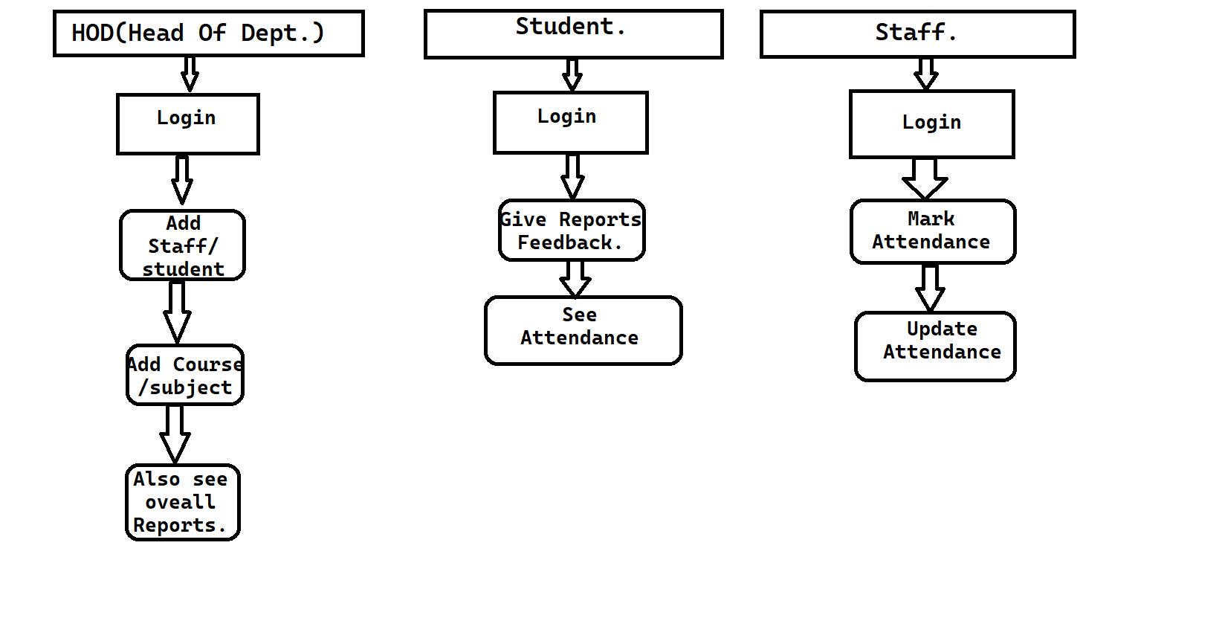

* This is AML Diagram for the Student Management System